

2020 CPL Systems National Roadrace Series schedule

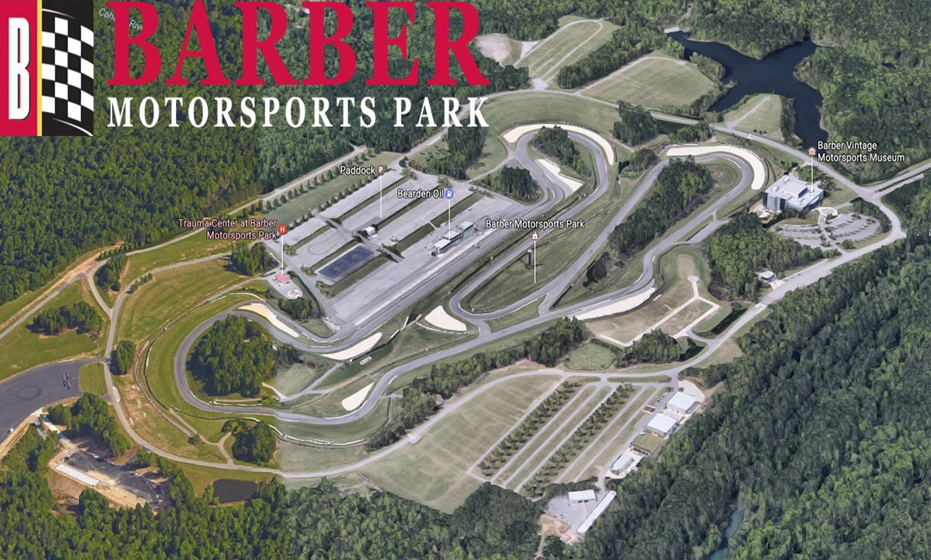

2/7-9 Laguna Seca; Monterey, CA
2/20-23 Roebling Road Raceway; Bloomingdale, GA
3/27-29 Carolina Motorsports Park; Kershaw, SC
4/17-19 Streets of Willow; Rosamond, CA
4/24-26 Willow Springs International Raceway; Rosamond, CA
5/22-24 Heartland Park, Topeka, KS
6/19-21 New Jersey Motorsports Park; Millville, NJ
7/24-26 Blackhawk Farms Raceway, South Beloit, IL
7/31-8/2 Gingerman Raceway, South Haven, MI
9/11-13 Talladega Gran Prix Raceway; Munford, AL
10/8-11 Barber Motorsports Park; Birmingham, AL

*AHRMA run Friday practice
**Mandatory practice days Thursday and Friday; no school

